Digibird Eyeview Analysis Tool Program Manual

Welcome to your new digital life!

Thank you for choosing to use Digibird Eyeview for your analysis needs. This tool has been created to help you analyse the 2018 Kraggle scraped Airbnb datasets.

This tool comes pre-loaded with the datasets to get you up and running as soon as possible. You do not need to download or install the data files to your computer.

To run Digibird Eyeview simply:

- Unzip the files to a folder anywhere on your computer

- Open the folder in file explorer

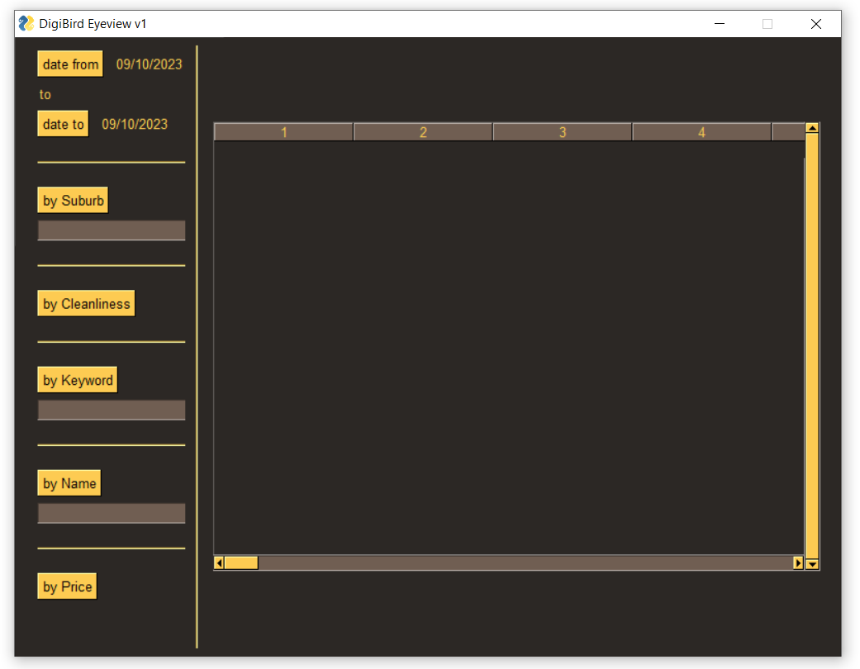- Double click ‘main.exe’

You will be presented with a window

that looks like this.

This is the main application window.

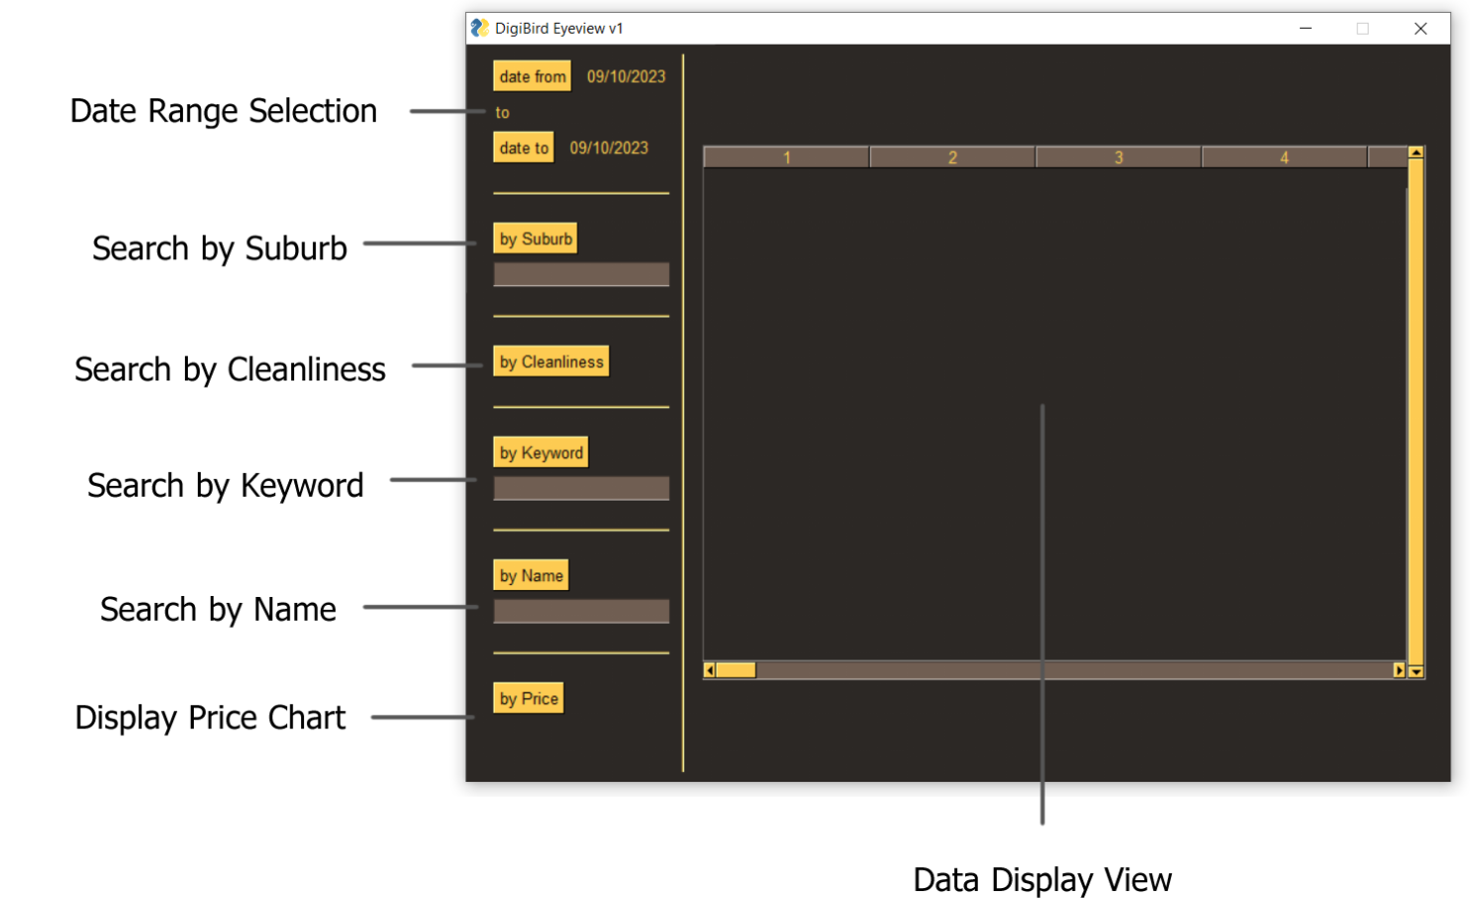

Main application window

The main application window allows you to select a date range, and view data in the Data Display View with multiple options.

**Date Range Selection**

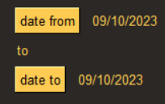

This shows the current date range selected.

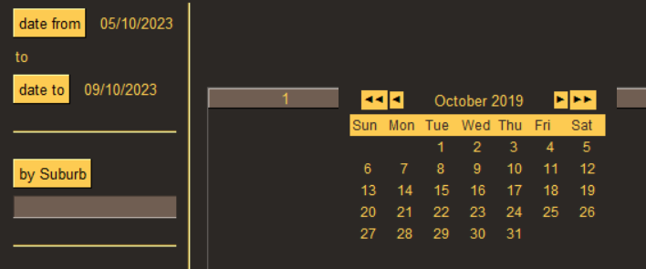

To change either side of the date range, click either

button, and a calendar will appear. Simply select the

desired date from the calendar, and the date will adjust.

**Search By Suburb**

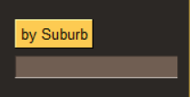

This allows you to search for listings in a specific suburb

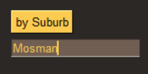

To use this tool, type your suburb into the box below while

you have your desired date range in the date selector,

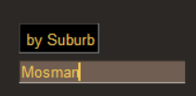

then click the ‘by Suburb’ button.

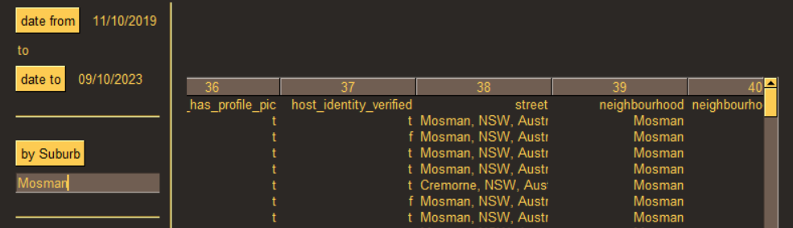

You will then be presented with a list of entries from that suburb within the date range.

**Search by Cleanliness**

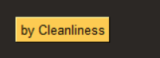

This tool allows you to show listings rated by

cleanliness percentage, as determined by review commentary,

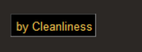

To use this tool, simply click the button,

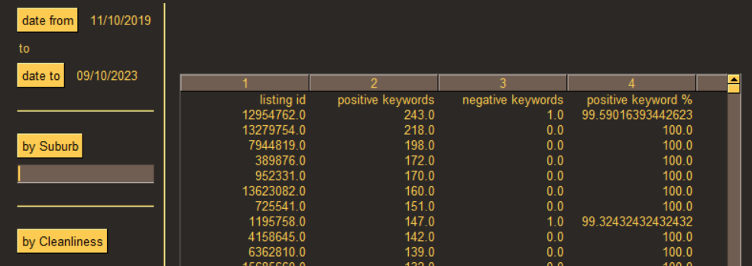

You will be presented with a list of all listings, the amount of positive and negative keywords contained in their reviews, and the percentage of positive keywords to negative keywords.

**Search by Keyword**

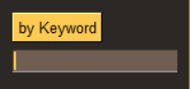

This tool allows you to search for listings containing a specific

keyword.

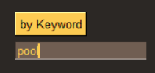

To use this tool, type your keyword into the box below while

you have your desired date range in the date selector,

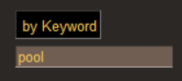

Then click the ‘by Keyword’ button,

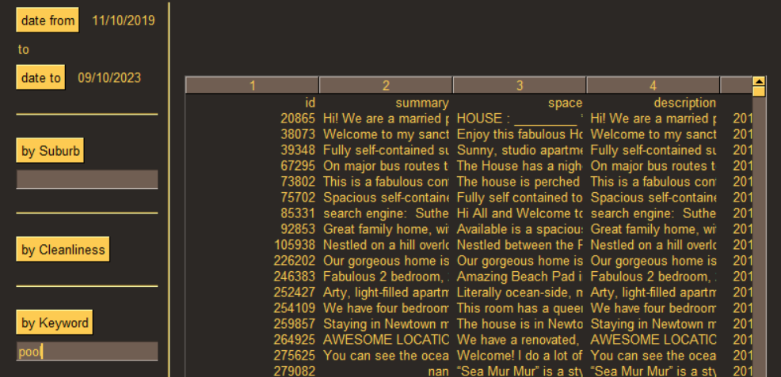

You will be presented with a list of all listings that contain the keyword within the date range.

**Search by Name**

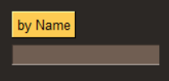This tool allows you to search for listings by a specific

name.

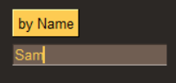

To use this tool, type the name into the box below while

you have your desired date range in the date selector,

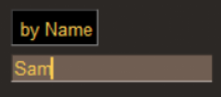

Then, click the ‘by Name’ button,

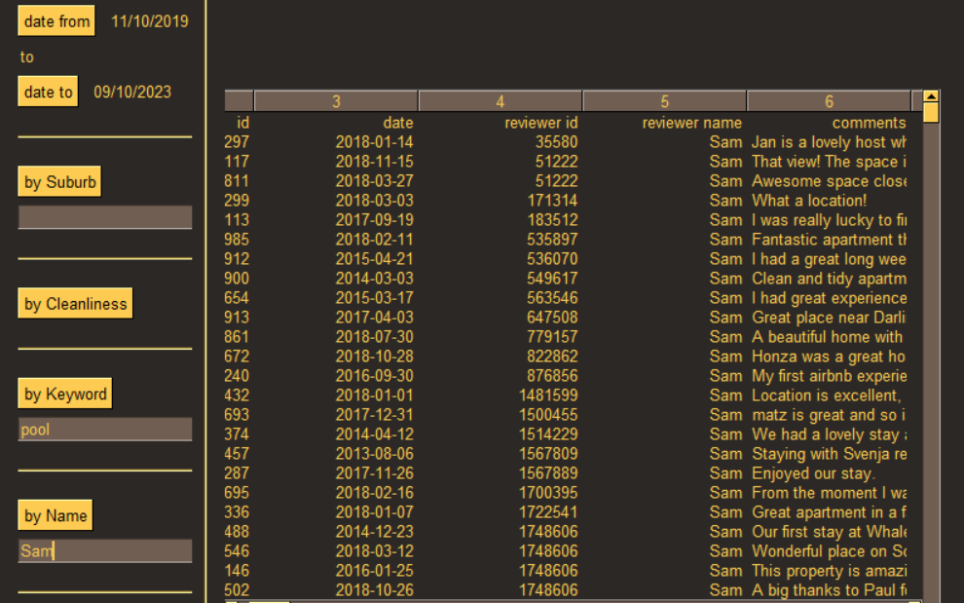

You will be presented with a list of all listings that contain the name within the date range.

**Display Price Chart**



This tool allows you to view a chart that displays the distribution

of property prices



To use this tool, select your desired date range, and click the

‘by Price’ Button

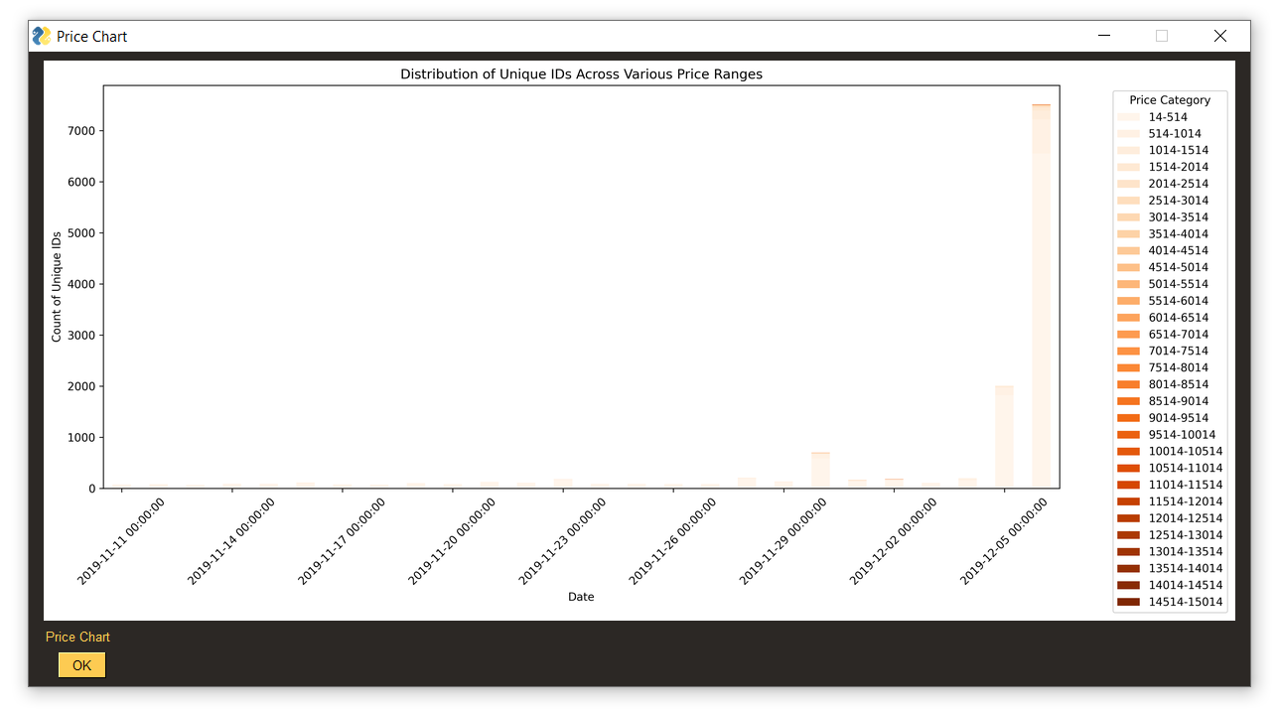

You will be presented with a popup that displays the chart image. To dismiss this popup, click the ‘OK’ button